**Texas Holdem Game Rules**

**Basic Rules:**

The object of the game is for players to form a five-card poker hand that ranks higher than the other players’ five-card poker hands. Each player may use any combination of the two cards initially dealt to them at the beginning of the game and the five cards dealt on the table throughout the course of the game, referred to as the community cards. Players are allowed to use the five community cards to make the highest ranking five-card poker hand.

**Card Rankings:**

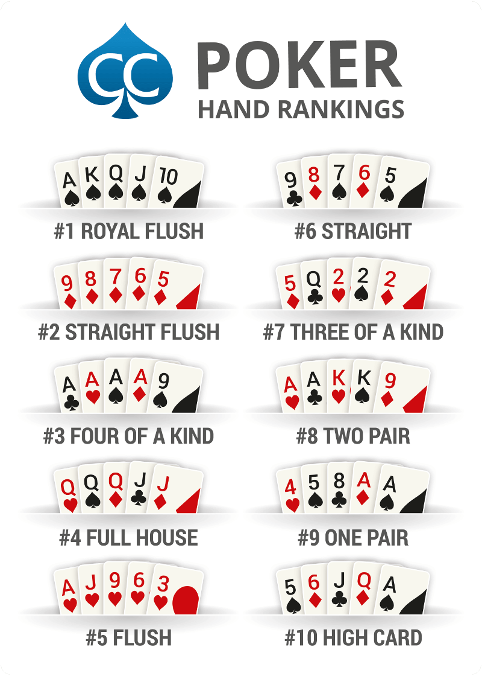

**In Game Actions:**

During each round of the game, players have the choice of action:

Fold – forfeiting the cards dealt to them

Check – no action

Bet – wagering money and increasing the pot value

Call – matching opponent’s bet

Raise – wager more money than your opponents and increasing the pot value

Once all players have made the same amount of bet and all 5 community cards are shown, the round ends and the pot is given to the player with the highest hand.

If more than one player has the same highest hand, then the pot will be evenly distributed amongst them.